INSTALL AND UPGRADE

1. Download and install ignition from [Download Ignition by Inductive Automation](https://inductiveautomation.com/downloads/)
2. Same process to upgrade ignition will recognize and do in place upgrade
3. Default credentials are user:Admin password:password
4. Required modules for app installation.

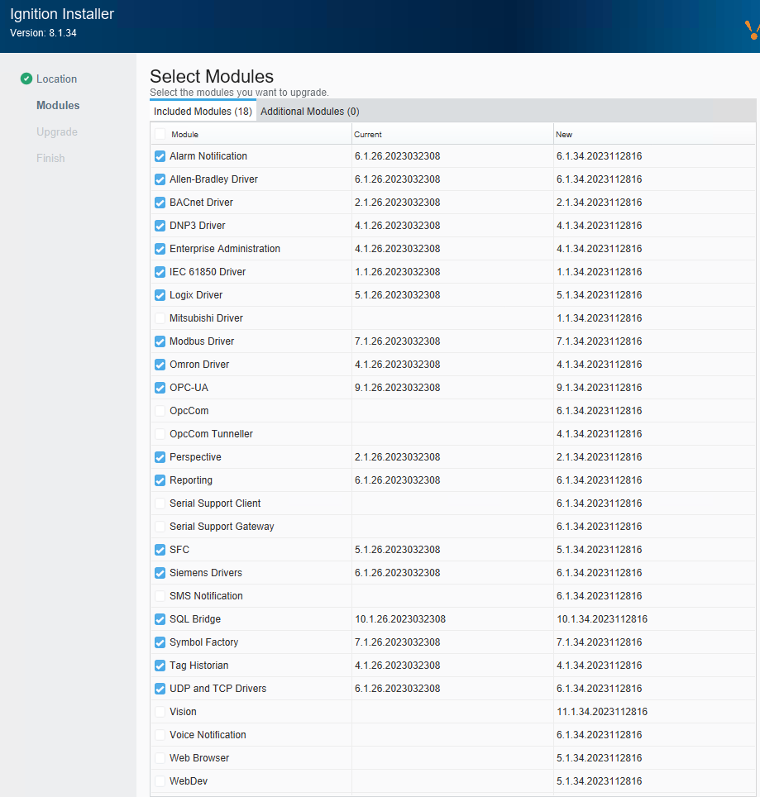

1. Modify the following files to configure Ignition

"C:\Program Files\Inductive Automation\Ignition\lib\runtime\jre-win\conf\security\java.security"

* Recommended to increase memory allocation to following values in this file

# Initial Java Heap Size (in MB)

wrapper.java.initmemory=4096

# Maximum Java Heap Size (in MB)

wrapper.java.maxmemory=8192

"C:\Program Files\Inductive Automation\Ignition\data\ignition.conf"

* Enable ‘rsa_pkcs1_sha1, secp224r1’ by removing from disabled algos

# jdk.tls.disabledAlgorithms=MD5, SSLv3, DSA, RSA keySize < 2048, \

# rsa_pkcs1_sha1, secp224r1

jdk.tls.disabledAlgorithms=SSLv3, TLSv1, TLSv1.1, RC4, DES, MD5withRSA, \

DH keySize < 1024, EC keySize < 224, 3DES_EDE_CBC, anon, NULL

1. Gateway setting configuration



